What is phonics?
Phonics Guidance for Parents 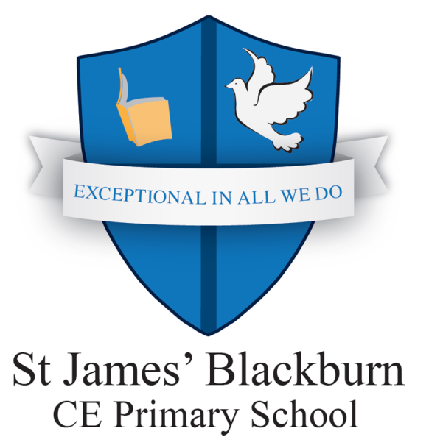

There are 26 letters of the alphabet- 5 vowels (a, e, I, o and u) and 21 consonants (b,c,d,f,g,h,j,k,l,m,n,p,q,r,s,t,v,w,x,y and z) but 44 different phonemes altogether. Each one of the 26 letters in the alphabet has its own ‘sound'. This is very different to how a letter is ‘said' in the alphabet. It is important to understand this difference between letter names and letter sounds. Some of these phonemes (sounds) are made up of 2 or 3 letters. 2 letter sounds are called digraphs and three letter sounds are called trigraphs. If you didn't learn to read using phonics it can seem very complicated, but once the concept of words being made up of just 44 sounds is understood, children are able to make remarkably quick progress in their reading. As learning progresses, children are taught simple, single letter sounds from the alphabet, before moving on to learning about digraphs, trigraphs and split digraphs.
Phonics terms you will need to know
consonants – b, c, d, f, g, h, j, k, l, m, n, p, q, r, s, t, v, w, x, y, z vowels – a, e, i, o, u
phoneme - a sound as it is said e.g. /n/ is pronounced ‘nnnn’ not ‘nuh’
grapheme – individual letters and combinations of letters written down that represent phonemes, there may be more than one grapheme for a sound , e.g. day, pain
digraph - a grapheme that has two letters that work together to make the same sound e.g. chip
split digraph - a grapheme that has two letters that work together to make the same sound, separated by another letter e.g. cake or home. Fortunately ‘split digraphs' always end with an ‘e' which does make them a little easier to spot!
trigraph - a grapheme that has three letters that work together to make the same sound e.g. night
segmenting - breaking up a word into its sounds
blending – putting the sounds together to read a word
phonetically decodable – words that can be sounded out using phonic skills and knowledge.
tricky words – Words that cannot be sounded out accurately. Children should be encouraged to identify the parts of a word which are phonetically regular and identify the parts of the word which are ‘tricky’.
Why is my child taught phonics?
Phonics makes learning to read easier, simpler and crucially gets children reading quicker. This helps to increase a child's confidence and instil a love of reading from an early age. Reading is the foundation of all education. When children can read, other subjects then become available to them and independent learning can begin. Those who are unable to read well will find themselves at a constant disadvantage throughout their education. Phonics is the ‘building blocks’ for reading. Phonics is also important when writing. Children are taught and encouraged to spell phonetically before they spell correctly, as this shows an understanding of how words are made up of sounds, and that different letters make certain sounds.
Phonics teaching and learning is organised into six phases as detailed in the following table.

Phase 1 – Nursery Phase One activities pave the way for the systematic teaching of phonic work to begin in Phase Two. Phase One activities are designed to underpin and run alongside activities in other phases.
Aspect 1: General sound discrimination – environmental sounds ( listening walks, I can hear…)
Aspect 2: General sound discrimination – instrumental sounds (playing with real or homemade instruments)
Aspect 3: General sound discrimination – body percussion (clapping/stamping/clicking)
Aspect 4: Rhythm and rhyme (cat/sat/bat/pat)
Aspect 5: Alliteration (big bad bear)
Aspect 6: Voice sounds ( be a steam train – chchchchch, hiss like a snake – sssssss)
Aspect 7: Oral blending and segmenting (c- a – t)

Phase 2 - Reception Develops children's knowledge of grapheme-phoneme correspondences (GPCs). Teaches and practices the skills of blending separate sounds together into whole words for reading and segmenting whole words into separate sounds for spelling.
Letter progression
Set 1: s, a, t, p Set 2: i, n, m, d Set 3: g, o, c, k Set 4: ck, e, u, r Set 5: h, b, f, ff, l, ll, ss
Words made using set 1: sat, pat, tap, sap
Words made using sets 1 - 2: (+ i) it, is, sit, pit, pip, sip, tip (+n) an, in, nip, pan, pin, tan, nap, tin, ( +m) am, man, mat, map, Pam, Tim, Sam (+d) dad, sad, dim, din, did, Sid, and dip
Words using sets 1 -3 (+g) tag, gag, gig, gap, nag, sag, gas, pig, dig (+o) got, on, not, pot, top, dog, tot, pop, mog (+c) can, cot, cop, cap, cat, cod (+k) kid, kit, Kim, Ken
Words using sets 1 -4 ( +ck) kick, sock, sack, dock, sick, pick, pack, tuck (+e) get, pet, ten, net, pen, peg, met, men ( +u) up, mum, run, mug, cup, sun, mud (+r) rim, rip, ram, rat, rag, rug, rot
Words using sets 1- 5 ( +h) had, him, his, hot, hut, hop, hum, hit, hat, has, hack (+b) but, big, back, bet, bad, bag, bed, bud, beg, bug, bun (+f and ff) of, if, off, fit, fin, fun, fig, fog, puff, huff, cuff (+l and ll) lap, let, leg, lot, lit, bell, fill, doll, tell, sell, Bill (+ss) less, hiss, mass, mess, boss, fuss, hiss, pass, kiss, Tess

Phase 2 Tricky words: I, the, to, go, no
Phase 3 - Reception
By the time children reach Phase 3, they will already be able to blend and segment words containing the 19 letters taught at Phase 2. Phase 3 introduces 25 new graphemes, one at a time.
Letter progression
Set 6: j, v, w, x jam, vet, win, box
Set 7: y, z, zz, qu yes, zip, buzz, quick
Consonant digraphs: ch, sh, th, ng, chop, ship, thin, song
Vowel digraphs: ai train, ee tree, igh night, oa coat, oo (long) boot, oo (short) cook, ar star, or fork, ur
curl, ow now, oi spoil, ear hear, air fair, ure pure, er term
Phase 3 Tricky words: we, me, be, was, no, go, my, you, they, her, all, are
Phase 4 – Reception By Phase 4, children will be able to represent each of the 42 phonemes with a grapheme. There are no new GPCs to be learnt in this phase. They will blend phonemes to read CVC words and segment CVC words for spelling. They will also be able to read two syllable words that are simple and read all the tricky words so far and be able to spell some of them.
Practise recognition and recall of Phase 2 & 3 graphemes and reading and spelling CVC words.
Teach blending and segmentation of adjacent consonants.
Teach and practise reading & spelling CVCC words.
Reading common high frequency words.
Tricky words:
said, so, he, she, we, me, be, have, like, some, come, was, you, were, there, little, one, they, are, all, do, when, out, what, my, her.

Phase 5 - Year One Children will be taught new graphemes and alternative pronunciations for these graphemes as well as graphemes they already know. They will begin to learn to choose the appropriate grapheme when spelling as well as saying the sound when shown any grapheme that has been taught and writing the grapheme for any given sound. They will be able to apply phonics knowledge to read and spell unfamiliar words.

Practise recognition and recall of Phase 2, 3 & 5 graphemes (as learned).
Learn new phonemes:
ay day, ou out, ie tie, ea eat, oy boy, ir girl,
ue blue, aw saw, wh when, ph photo, ew new, oe toe, au Paul
Split digraphs: a-e make, e-e these, i-e like, o-e home, u-e rule
Teach alternative pronunciations for graphemes: i mind, o closed, c city, g giant, u unicorn, ow grow, ie field, ea bread, er serve , a path acorn wasp, y sunny sky gym, ch school chef, ou could shoulder, ey grey

Tricky words: oh, their, people, Mr, Mrs, looked, called, asked, could

Phase 6: Year Two Phase 6 increases fluency when blending words encountered for the first time in reading and increases the accuracy of spelling choices. In Phase 6, there is a focus on learning spelling rules for word endings (these are known as suffixes). The children will learn how words change when you add certain letters. There are 12 different suffixes taught.
Investigate and learn how to add suffixes:
-s , -es , -ing , -ed , -s , -er , -est , -y , -en , -ful , -ly , -ment , -ness

Phonics at home – How to help your child
- Play I- Spy, ‘I-Spy with my little eye something starting with the sound…’
- Making and playing pairs games
- Odd one out – children identify a word which doesn’t share the same phoneme/grapheme
- Word searches
- Sorting words
- Countdown – give them phonemes they know and see if can make words.
- Hide and seek – write words/phonemes on cards which relate to particular phoneme or words you want them to practice, hide words and children have to find them and read them. They could also play this game where they have to spell the words and them hide them for someone else to find
- Enjoy reading aloud stories together

Top Tips

- When you talk to your child about letters, remember to use the letter sounds: a, buh, cuh,, duh, e… rather than the letter names of the alphabet: ay, bee, see, dee, ee… this will help your child to segment (sound out ) words accurately
- Distinguish and separate phonemes e.g. ‘s’ ‘t’ not ‘st’, with the exception of ‘qu’ ‘th’ ‘sh’ ‘ch’
- Help your child to think about where the sound is made and the position of the lips, teeth or tongue
- Some children will make very sensible attempts at spellings and may use letters that can represent a phoneme but they might not use the correct one e.g. ‘sean’ instead of ‘seen’. Always praise attempts and where appropriate select some to sensitively correct

Useful Websites

http://www.letters-and-sounds.com

http://www.phonicsplay

http://www.topmarks.co.uk
www.jollylearning.co.uk/overview-about-jolly-phonics
Thank you for taking the time to read this guidance.
We really hope it helps you to support your child in their phonics learning. If you have any questions about reading or are concerned about your child’s progress in Phonics, please speak to your child’s class teacher or Mrs Madbouli (Core Curriculum Leader and Assistant Head Teacher).

